Network Device

Draw and label a simple home network diagram showing a router, switch, and three devices (like a laptop, smartphone, and smart TV), indicating how each device connects to the network.
Ans :
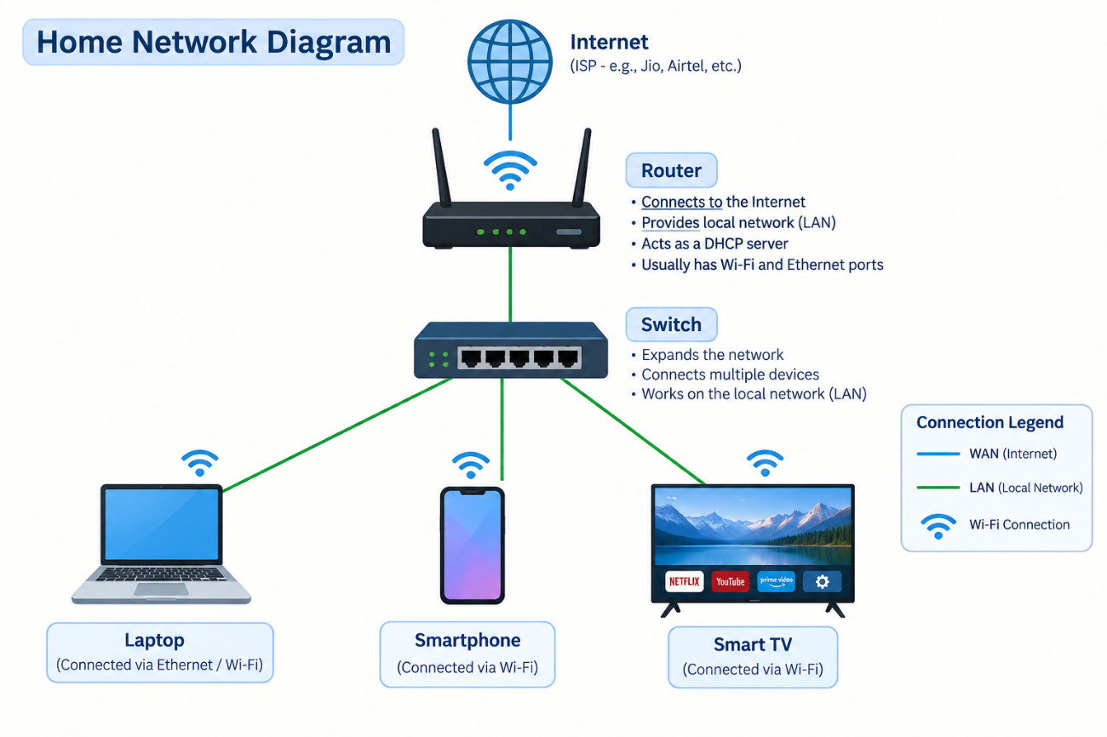

Create a comparison table listing at least four network devices (router, switch, hub, access point) and describe one real-world use case for each, referencing apps or services you use daily (e.g., WiFi for streaming on YouTube, LAN gaming, etc.).
Ans :
Network Device | Main Function | One Real-World Use Case | Daily App/Service Example
Router | Connects different networks and provides Internet access. | Connects a home network to the Internet. | YouTube: Your phone or laptop uses the router to access YouTube videos.
Switch | Connects multiple devices within a LAN. | Connects PCs, printers, and servers in an office. | LAN Gaming: Multiple computers can connect through a switch to play games on the same local network.
Hub | Connects multiple devices and broadcasts data to all connected devices. | Used in simple or older small LANs for connecting computers. | File Sharing: Computers connected to a hub can communicate and share files on a local network.
Access Point (AP) | Provides wireless/Wi-Fi access to a network. | Provides Wi-Fi coverage in homes, offices, schools, and public places. | YouTube/Instagram: A smartphone connects to the Wi-Fi AP to stream videos or browse Instagram.

Write a short scenario where you explain how data travels from your phone to the internet when you order food on Zomato, mentioning the role of each network device involved (router, switch, access point).
Ans :
Scenario: Ordering Food on Zomato
Suppose I open the Zomato app on my smartphone and order a pizza.
- Access Point (AP): My phone connects to the home Wi-Fi through the Access Point. It sends my order data to the local network wirelessly.
- Switch: The data may pass through a switch in the local network or ISP infrastructure. The switch forwards the data to the correct network device.
- Router: The router receives the data and forwards it from my local network to the Internet. It helps the data reach Zomato's servers.
- Internet: Zomato's server receives my order, processes it, and sends a response back.
- Return: The response travels back through the Internet → router → Wi-Fi access point → my smartphone. I then see the order confirmation in the Zomato app.
Flow:
📱 Phone → 📶 Access Point → 🔀 Switch → 🌐 Router → ☁️ Internet → Zomato Server

Given this situation: you have a WiFi router, but your gaming PC only has an Ethernet port and is far from the router. Suggest two different network devices you could use to connect your PC to the internet and explain how each would work in this setup.<br><br><em><strong>Hint:</strong> Think about devices like switches, powerline adapters, or WiFi extenders.</em>
Ans :
Solution
If my gaming PC has only an Ethernet port and is far from the Wi-Fi router, I can use these two devices:
Device | How it works
1. Powerline Adapter | I connect one powerline adapter to the router using an Ethernet cable and plug it into a power socket. I plug the second adapter near my gaming PC and connect it to the PC using an Ethernet cable. It uses the home's electrical wiring to carry the network connection.
2. Wi-Fi Extender with Ethernet Port | I place the Wi-Fi extender between the router and the gaming PC. The extender receives the Wi-Fi signal from the router and provides an Ethernet port. I connect my gaming PC to this port using an Ethernet cable.
Simple diagrams
Powerline Adapter:
Router → Ethernet → Powerline Adapter → Electrical Wiring → Powerline Adapter → Ethernet → Gaming PC
Wi-Fi Extender:
Router 📶 → Wi-Fi Extender → Ethernet Cable → Gaming PC
Best choice for gaming: A powerline adapter can be a good option when running a long Ethernet cable is difficult, although actual performance depends on the home's electrical wiring.

